**MongoDB Assignment 3**

**Questions:**

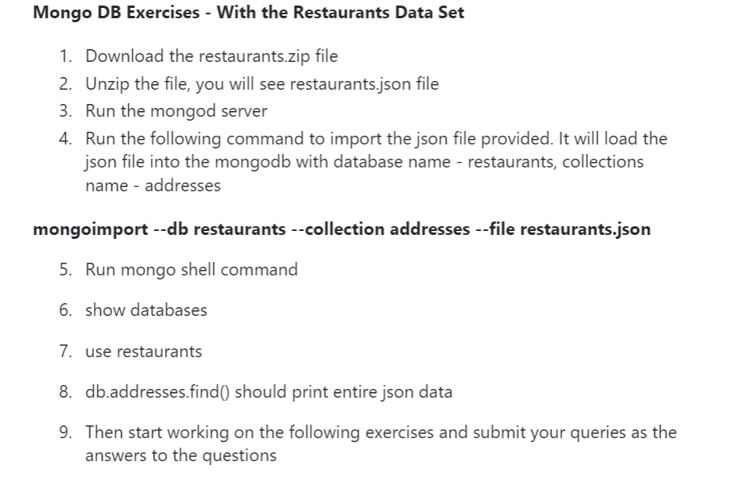

**Comments & Results:**

**> use CheapAndBest**

switched to db CheapAndBest

> show collections;

restaurants

**> db.restaurants.find().pretty()**

{

"_id" : ObjectId("60e1322cb0aed98e1e7af715"),

"address" : {

"building" : "1007",

"coord" : [

-73.856077,

40.848447

],

"street" : "Morris Park Ave",

"zipcode" : "10462"

},

"borough" : "Bronx",

"cuisine" : "Bakery",

"grades" : [

{

"date" : ISODate("2014-03-03T00:00:00Z"),

"grade" : "A",

"score" : 2

},

{

"date" : ISODate("2013-09-11T00:00:00Z"),

"grade" : "A",

"score" : 6

},

{

"date" : ISODate("2013-01-24T00:00:00Z"),

"grade" : "A",

"score" : 10

},

{

"date" : ISODate("2011-11-23T00:00:00Z"),

"grade" : "A",

"score" : 9

},

{

"date" : ISODate("2011-03-10T00:00:00Z"),

"grade" : "B",

"score" : 14

}

],

"name" : "Morris Park Bake Shop",

"restaurant_id" : "30075445"

}

{

"_id" : ObjectId("60e1322cb0aed98e1e7af716"),

"address" : {

"building" : "469",

"coord" : [

-73.961704,

40.662942

],

"street" : "Flatbush Avenue",

"zipcode" : "11225"

},

"borough" : "Brooklyn",

"cuisine" : "Hamburgers",

"grades" : [

{

"date" : ISODate("2014-12-30T00:00:00Z"),

"grade" : "A",

"score" : 8

},

{

"date" : ISODate("2014-07-01T00:00:00Z"),

"grade" : "B",

"score" : 23

},

{

"date" : ISODate("2013-04-30T00:00:00Z"),

"grade" : "A",

"score" : 12

},

{

"date" : ISODate("2012-05-08T00:00:00Z"),

"grade" : "A",

"score" : 12

}

],

"name" : "Wendy'S",

"restaurant_id" : "30112340"

}

**Questions:**

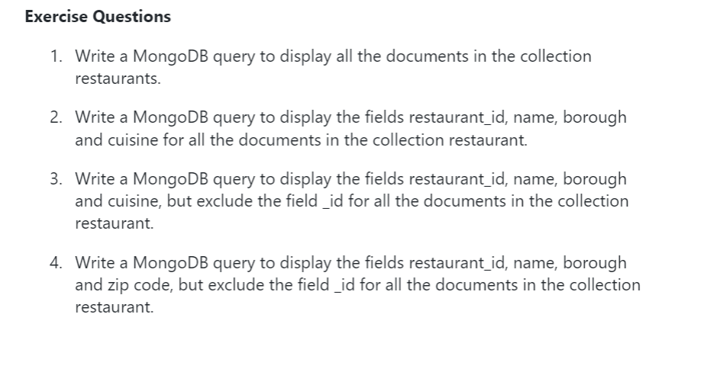

**Comments & Results:**

**> db.restaurants.find({},{"restaurant_id":1,"name":1,"borough":1,"cuisine":1}).pretty()**

{

"_id" : ObjectId("60e1322cb0aed98e1e7af715"),

"borough" : "Bronx",

"cuisine" : "Bakery",

"name" : "Morris Park Bake Shop",

"restaurant_id" : "30075445"

}

{

"_id" : ObjectId("60e1322cb0aed98e1e7af716"),

"borough" : "Brooklyn",

"cuisine" : "Hamburgers",

"name" : "Wendy'S",

"restaurant_id" : "30112340"

}

{

"_id" : ObjectId("60e1322cb0aed98e1e7af717"),

"borough" : "Manhattan",

"cuisine" : "Irish",

"name" : "Dj Reynolds Pub And Restaurant",

"restaurant_id" : "30191841"

}

{

"_id" : ObjectId("60e1322cb0aed98e1e7af718"),

"borough" : "Brooklyn",

"cuisine" : "American ",

"name" : "Riviera Caterer",

"restaurant_id" : "40356018"

}....continues

**db.restaurants.find({},{"restaurant_id":1,"name":1,"borough":1,"cuisine":1,"_id":0}).pretty()**

{

"borough" : "Bronx",

"cuisine" : "Bakery",

"name" : "Morris Park Bake Shop",

"restaurant_id" : "30075445"

}

{

"borough" : "Brooklyn",

"cuisine" : "Hamburgers",

"name" : "Wendy'S",

"restaurant_id" : "30112340"

}

{

"borough" : "Manhattan",

"cuisine" : "Irish",

"name" : "Dj Reynolds Pub And Restaurant",

"restaurant_id" : "30191841"

}

{

"borough" : "Brooklyn",

"cuisine" : "American ",

"name" : "Riviera Caterer",

"restaurant_id" : "40356018"

}...continues..

**db.restaurants.find({},{"restaurant_id":1,"name":1,"borough":1,"cuisine":1,"_id":0,"address.zipcode":1}).pretty()**

{

"address" : {

"zipcode" : "10462"

},

"borough" : "Bronx",

"cuisine" : "Bakery",

"name" : "Morris Park Bake Shop",

"restaurant_id" : "30075445"

}

{

"address" : {

"zipcode" : "11225"

},

"borough" : "Brooklyn",

"cuisine" : "Hamburgers",

"name" : "Wendy'S",

"restaurant_id" : "30112340"

}

**Questions:**

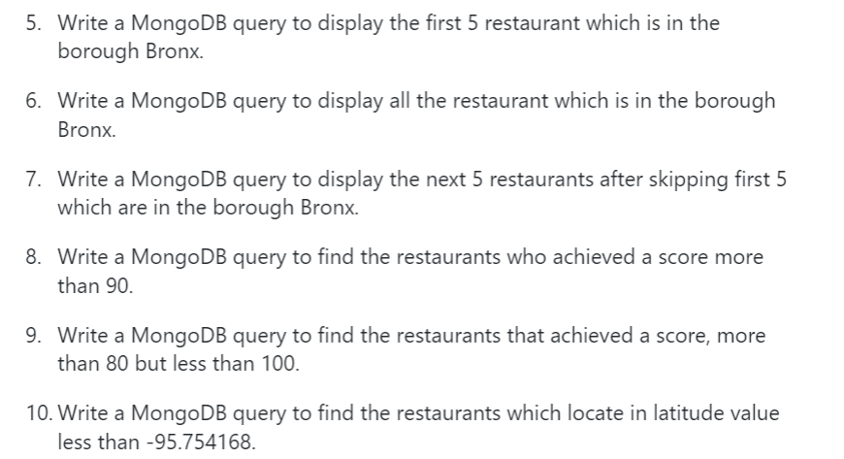

**Comments & Results:**

**> db.restaurants.aggregate([{$match:{"borough":"Bronx"}},{$limit:5}]).pretty()**

{

"_id" : ObjectId("60e1322cb0aed98e1e7af715"),

"address" : {

"building" : "1007",

"coord" : [

-73.856077,

40.848447

],

"street" : "Morris Park Ave",

"zipcode" : "10462"

},

"borough" : "Bronx",

"cuisine" : "Bakery",

"grades" : [

{

"date" : ISODate("2014-03-03T00:00:00Z"),

"grade" : "A",

"score" : 2

},

{

"date" : ISODate("2013-09-11T00:00:00Z"),

"grade" : "A",

"score" : 6

},

{

"date" : ISODate("2013-01-24T00:00:00Z"),

"grade" : "A",

"score" : 10

},

{

"date" : ISODate("2011-11-23T00:00:00Z"),

"grade" : "A",

"score" : 9

},

{

"date" : ISODate("2011-03-10T00:00:00Z"),

"grade" : "B",

"score" : 14

}

],

"name" : "Morris Park Bake Shop",

"restaurant_id" : "30075445"

}....continues

**db.restaurants.aggregate([{$match:{"borough":"Bronx"}},{$skip:5},{$limit:5}]).pretty()**

{

"_id" : ObjectId("60e1322cb0aed98e1e7af752"),

"address" : {

"building" : "658",

"coord" : [

-73.81363999999999,

40.82941100000001

],

"street" : "Clarence Ave",

"zipcode" : "10465"

},

"borough" : "Bronx",

"cuisine" : "American ",

"grades" : [

{

"date" : ISODate("2014-06-21T00:00:00Z"),

"grade" : "A",

"score" : 5

},

{

"date" : ISODate("2012-07-11T00:00:00Z"),

"grade" : "A",

"score" : 10

}

],

"name" : "Manhem Club",

"restaurant_id" : "40364363"

}....continues..

**> db.restaurants.find({"grades.score":{$gt:90}}).pretty()**

{

"_id" : ObjectId("60e1322cb0aed98e1e7af873"),

"address" : {

"building" : "65",

"coord" : [

-73.9782725,

40.7624022

],

"street" : "West 54 Street",

"zipcode" : "10019"

},

"borough" : "Manhattan",

"cuisine" : "American ",

"grades" : [

{

"date" : ISODate("2014-08-22T00:00:00Z"),

"grade" : "A",

"score" : 11

},

{

"date" : ISODate("2014-03-28T00:00:00Z"),

"grade" : "C",

"score" : 131

},

{

"date" : ISODate("2013-09-25T00:00:00Z"),

"grade" : "A",

"score" : 11

},

{

"date" : ISODate("2013-04-08T00:00:00Z"),

"grade" : "B",

"score" : 25

},

{

"date" : ISODate("2012-10-15T00:00:00Z"),

"grade" : "A",

"score" : 11

},

{

"date" : ISODate("2011-10-19T00:00:00Z"),

"grade" : "A",

"score" : 13

}

],

"name" : "Murals On 54/Randolphs'S",

"restaurant_id" : "40372466"

}...continues..

**db.restaurants.find({$and:[{"grades.score":{$gt:80}},{"grades.score":{$lt:100}}]}).pretty()**

{

"_id" : ObjectId("60e1322cb0aed98e1e7af873"),

"address" : {

"building" : "65",

"coord" : [

-73.9782725,

40.7624022

],

"street" : "West 54 Street",

"zipcode" : "10019"

},

"borough" : "Manhattan",

"cuisine" : "American ",

"grades" : [

{

"date" : ISODate("2014-08-22T00:00:00Z"),

"grade" : "A",

"score" : 11

},

{

"date" : ISODate("2014-03-28T00:00:00Z"),

"grade" : "C",

"score" : 131

},

{

"date" : ISODate("2013-09-25T00:00:00Z"),

"grade" : "A",

"score" : 11

},

{

"date" : ISODate("2013-04-08T00:00:00Z"),

"grade" : "B",

"score" : 25

},

{

"date" : ISODate("2012-10-15T00:00:00Z"),

"grade" : "A",

"score" : 11

},

{

"date" : ISODate("2011-10-19T00:00:00Z"),

"grade" : "A",

"score" : 13

}

],

"name" : "Murals On 54/Randolphs'S",

"restaurant_id" : "40372466"

}...continues....

**db.restaurants.find({"address.coord":{$lt:-95.754168}}).pretty()**

{

"_id" : ObjectId("60e1322cb0aed98e1e7afd5d"),

"address" : {

"building" : "3707",

"coord" : [

-101.8945214,

33.5197474

],

"street" : "82 Street",

"zipcode" : "11372"

},

"borough" : "Queens",

"cuisine" : "American ",

"grades" : [

{

"date" : ISODate("2014-06-04T00:00:00Z"),

"grade" : "A",

"score" : 12

},

{

"date" : ISODate("2013-11-07T00:00:00Z"),

"grade" : "B",

"score" : 19

},

{

"date" : ISODate("2013-05-17T00:00:00Z"),

"grade" : "A",

"score" : 11

},

{

"date" : ISODate("2012-08-29T00:00:00Z"),

"grade" : "A",

"score" : 11

},

{

"date" : ISODate("2012-04-03T00:00:00Z"),

"grade" : "A",

"score" : 12

},

{

"date" : ISODate("2011-11-16T00:00:00Z"),

"grade" : "A",

"score" : 7

}

],

"name" : "Burger King",

"restaurant_id" : "40534067"

}..continue,,,

**Questions:**

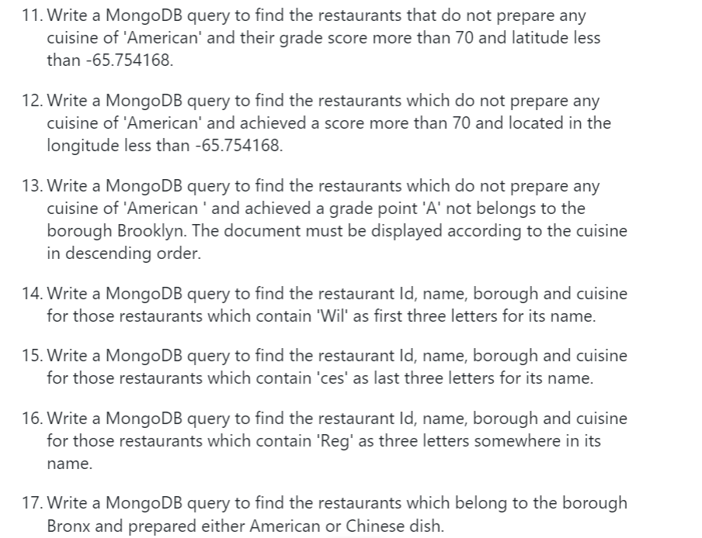

**Comments & Results:**

**db.restaurants.find(**

**... {$and:**

**... [**

**... {"cuisine" : {$ne :"American "}},**

**... {"grades.score" : {$gt : 70}},**

**... {"address.coord" : {$lt : -65.754168}}**

**... ]**

**... }**

**... ).pretty()**

{

"_id" : ObjectId("60e1322cb0aed98e1e7af914"),

"address" : {

"building" : "345",

"coord" : [

-73.9864626,

40.7266739

],

"street" : "East 6 Street",

"zipcode" : "10003"

},

"borough" : "Manhattan",

"cuisine" : "Indian",

"grades" : [

{

"date" : ISODate("2014-09-15T00:00:00Z"),

"grade" : "A",

"score" : 5

},

{

"date" : ISODate("2014-01-14T00:00:00Z"),

"grade" : "A",

"score" : 8

},

{

"date" : ISODate("2013-05-30T00:00:00Z"),

"grade" : "A",

"score" : 12

},

{

"date" : ISODate("2013-04-24T00:00:00Z"),

"grade" : "P",

"score" : 2

},

{

"date" : ISODate("2012-10-01T00:00:00Z"),

"grade" : "A",

"score" : 9

},

{

"date" : ISODate("2012-04-06T00:00:00Z"),

"grade" : "C",

"score" : 92

},

{

"date" : ISODate("2011-11-03T00:00:00Z"),

"grade" : "C",

"score" : 41

}

],

"name" : "Gandhi",

"restaurant_id" : "40381295"

}...continues...

**db.restaurants.find(**

**... {**

**... "cuisine" : {$ne : "American "},**

**... "grades.score" :{$gt: 70},**

**... "address.coord" : {$lt : -65.754168}**

**... }**

**... ).pretty()**

{

"_id" : ObjectId("60e1322cb0aed98e1e7af914"),

"address" : {

"building" : "345",

"coord" : [

-73.9864626,

40.7266739

],

"street" : "East 6 Street",

"zipcode" : "10003"

},

"borough" : "Manhattan",

"cuisine" : "Indian",

"grades" : [

{

"date" : ISODate("2014-09-15T00:00:00Z"),

"grade" : "A",

"score" : 5

},

{

"date" : ISODate("2014-01-14T00:00:00Z"),

"grade" : "A",

"score" : 8

},

{

"date" : ISODate("2013-05-30T00:00:00Z"),

"grade" : "A",

"score" : 12

},

{

"date" : ISODate("2013-04-24T00:00:00Z"),

"grade" : "P",

"score" : 2

},

{

"date" : ISODate("2012-10-01T00:00:00Z"),

"grade" : "A",

"score" : 9

},

{

"date" : ISODate("2012-04-06T00:00:00Z"),

"grade" : "C",

"score" : 92

},

{

"date" : ISODate("2011-11-03T00:00:00Z"),

"grade" : "C",

"score" : 41

}

],

"name" : "Gandhi",

"restaurant_id" : "40381295"

}..continues..

**db.restaurants.find( {**

**... "cuisine" : {$ne : "American "},**

**... "grades.grade" :"A",**

**... "borough": {$ne : "Brooklyn"}**

**... }**

**... ).sort({"cuisine":-1}).pretty()**

{

"_id" : ObjectId("60e1322cb0aed98e1e7afe21"),

"address" : {

"building" : "89",

"coord" : [

-73.9995899,

40.7168015

],

"street" : "Baxter Street",

"zipcode" : "10013"

},

"borough" : "Manhattan",

"cuisine" : "Vietnamese/Cambodian/Malaysia",

"grades" : [

{

"date" : ISODate("2014-08-21T00:00:00Z"),

"grade" : "A",

"score" : 13

},

{

"date" : ISODate("2013-08-31T00:00:00Z"),

"grade" : "A",

"score" : 13

},

{

"date" : ISODate("2013-04-11T00:00:00Z"),

"grade" : "C",

"score" : 3

},

{

"date" : ISODate("2012-10-17T00:00:00Z"),

"grade" : "A",

"score" : 4

},

{

"date" : ISODate("2012-05-15T00:00:00Z"),

"grade" : "A",

"score" : 10

}

],

"name" : "Thai Son",

"restaurant_id" : "40559606"

}..continues...

**db.restaurants.find(**

**... {name: /^Wil/},**

**... {**

**... "restaurant_id" : 1,**

**... "name":1,"borough":1,**

**... "cuisine" :1**

**... }**

**... ).pretty()**

{

"_id" : ObjectId("60e1322cb0aed98e1e7af71c"),

"borough" : "Brooklyn",

"cuisine" : "Delicatessen",

"name" : "Wilken'S Fine Food",

"restaurant_id" : "40356483"

}

{

"_id" : ObjectId("60e1322cb0aed98e1e7af71f"),

"borough" : "Bronx",

"cuisine" : "American ",

"name" : "Wild Asia",

"restaurant_id" : "40357217"

}

{

"_id" : ObjectId("60e1322db0aed98e1e7b0524"),

"borough" : "Bronx",

"cuisine" : "Pizza",

"name" : "Wilbel Pizza",

"restaurant_id" : "40871979"

}

**db.restaurants.find(**

**... {name: /ces$/},**

**... {**

**... "restaurant_id" : 1,**

**... "name":1,"borough":1,**

**... "cuisine" :1**

**... }**

**... ).pretty()**

{

"_id" : ObjectId("60e1322cb0aed98e1e7afba8"),

"borough" : "Manhattan",

"cuisine" : "American ",

"name" : "Pieces",

"restaurant_id" : "40399910"

}

{

"_id" : ObjectId("60e1322cb0aed98e1e7afc67"),

"borough" : "Queens",

"cuisine" : "American ",

"name" : "S.M.R Restaurant Services",

"restaurant_id" : "40403857"

}

{

"_id" : ObjectId("60e1322cb0aed98e1e7afc6d"),

"borough" : "Manhattan",

"cuisine" : "American ",

"name" : "Good Shepherd Services",

"restaurant_id" : "40403989"

}

{

"_id" : ObjectId("60e1322db0aed98e1e7b0120"),

"borough" : "Queens",

"cuisine" : "Ice Cream, Gelato, Yogurt, Ices",

"name" : "The Ice Box-Ralph'S Famous Italian Ices",

"restaurant_id" : "40690899"

}

{

"_id" : ObjectId("60e1322db0aed98e1e7b0322"),

"borough" : "Brooklyn",

"cuisine" : "Jewish/Kosher",

"name" : "Alices",

"restaurant_id" : "40782042"

}

{

"_id" : ObjectId("60e1322db0aed98e1e7b053e"),

"borough" : "Manhattan",

"cuisine" : "American ",

"name" : "Re: Sources",

"restaurant_id" : "40876068"

}

**db.restaurants.find(**

**... {"name": /.*Reg.*/},**

**... {**

**... "restaurant_id" : 1,**

**... "name":1,"borough":1,**

**... "cuisine" :1**

**... }**

**... ).pretty()**

{

"_id" : ObjectId("60e1322cb0aed98e1e7af71d"),

"borough" : "Brooklyn",

"cuisine" : "American ",

"name" : "Regina Caterers",

"restaurant_id" : "40356649"

}

{

"_id" : ObjectId("60e1322cb0aed98e1e7af81a"),

"borough" : "Manhattan",

"cuisine" : "Café/Coffee/Tea",

"name" : "Caffe Reggio",

"restaurant_id" : "40369418"

}

{

"_id" : ObjectId("60e1322cb0aed98e1e7af929"),

"borough" : "Manhattan",

"cuisine" : "American ",

"name" : "Regency Hotel",

"restaurant_id" : "40382679"

}

{

"_id" : ObjectId("60e1322cb0aed98e1e7afc46"),

"borough" : "Manhattan",

"cuisine" : "American ",

"name" : "Regency Whist Club",

"restaurant_id" : "40402377"

}

{

"_id" : ObjectId("60e1322cb0aed98e1e7afd29"),

"borough" : "Queens",

"cuisine" : "American ",

"name" : "Rego Park Cafe",

"restaurant_id" : "40523342"

}

{

"_id" : ObjectId("60e1322db0aed98e1e7b0397"),

"borough" : "Queens",

"cuisine" : "Pizza",

"name" : "Regina Pizza",

"restaurant_id" : "40801325"

}

{

"_id" : ObjectId("60e1322db0aed98e1e7b05ae"),

"borough" : "Manhattan",

"cuisine" : "American ",

"name" : "Regal Entertainment Group",

"restaurant_id" : "40891782"

}

**>db.restaurants.find(**

**... {**

**... "borough": "Bronx" ,**

**... $or : [**

**... { "cuisine" : "American " },**

**... { "cuisine" : "Chinese" }**

**... ]**

**... }**

**... ).pretty()**

{

"_id" : ObjectId("60e1322cb0aed98e1e7af71f"),

"address" : {

"building" : "2300",

"coord" : [

-73.8786113,

40.8502883

],

"street" : "Southern Boulevard",

"zipcode" : "10460"

},

"borough" : "Bronx",

"cuisine" : "American ",

"grades" : [

{

"date" : ISODate("2014-05-28T00:00:00Z"),

"grade" : "A",

"score" : 11

},

{

"date" : ISODate("2013-06-19T00:00:00Z"),

"grade" : "A",

"score" : 4

},

{

"date" : ISODate("2012-06-15T00:00:00Z"),

"grade" : "A",

"score" : 3

}

],

"name" : "Wild Asia",

"restaurant_id" : "40357217"

}..continues...

**Questions:**

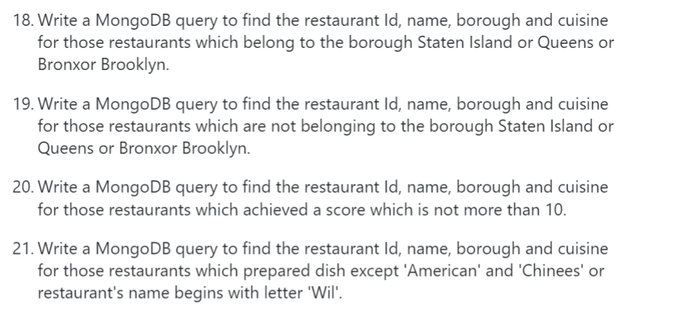

**Comments & Results:**

**db.restaurants.find(**

**... {"borough" :{$in :["Staten Island","Queens","Bronx","Brooklyn"]}},**

**... {**

**... "restaurant_id" : 1,**

**... "name":1,"borough":1,**

**... "cuisine" :1**

**... }**

**... ).pretty()**

{

"_id" : ObjectId("60e1322cb0aed98e1e7af715"),

"borough" : "Bronx",

"cuisine" : "Bakery",

"name" : "Morris Park Bake Shop",

"restaurant_id" : "30075445"

}

{

"_id" : ObjectId("60e1322cb0aed98e1e7af716"),

"borough" : "Brooklyn",

"cuisine" : "Hamburgers",

"name" : "Wendy'S",

"restaurant_id" : "30112340"

}...continues...

**db.restaurants.find(**

**... {"borough" :{$nin :["Staten Island","Queens","Bronx","Brooklyn"]}},**

**... {**

**... "restaurant_id" : 1,**

**... "name":1,"borough":1,**

**... "cuisine" :1**

**... }).pretty()**

{

"_id" : ObjectId("60e1322cb0aed98e1e7af717"),

"borough" : "Manhattan",

"cuisine" : "Irish",

"name" : "Dj Reynolds Pub And Restaurant",

"restaurant_id" : "30191841"

}

{

"_id" : ObjectId("60e1322cb0aed98e1e7af722"),

"borough" : "Manhattan",

"cuisine" : "American ",

"name" : "1 East 66Th Street Kitchen",

"restaurant_id" : "40359480"

}....continue...

**db.restaurants.find(**

**... {"grades.score" :**

**... { $not:**

**... {$gt : 10}**

**... }**

**... },**

**... {**

**... "restaurant_id" : 1,**

**... "name":1,"borough":1,**

**... "cuisine" :1**

**... }**

**... ).pretty()**

{

"_id" : ObjectId("60e1322cb0aed98e1e7af720"),

"borough" : "Brooklyn",

"cuisine" : "American ",

"name" : "C & C Catering Service",

"restaurant_id" : "40357437"

}

{

"_id" : ObjectId("60e1322cb0aed98e1e7af722"),

"borough" : "Manhattan",

"cuisine" : "American ",

"name" : "1 East 66Th Street Kitchen",

"restaurant_id" : "40359480"

}...continue,,,

**db.restaurants.find(**

**... {$or: [**

**... {name: /^Wil/},**

**... {"$and": [**

**... {"cuisine" : {$ne :"American "}},**

**... {"cuisine" : {$ne :"Chinees"}}**

**... ]}**

**... ]}**

**... ,{"restaurant_id" : 1,"name":1,"borough":1,"cuisine" :1}**

**... ).pretty()**

{

"_id" : ObjectId("60e1322cb0aed98e1e7af715"),

"borough" : "Bronx",

"cuisine" : "Bakery",

"name" : "Morris Park Bake Shop",

"restaurant_id" : "30075445"

}

{

"_id" : ObjectId("60e1322cb0aed98e1e7af716"),

"borough" : "Brooklyn",

"cuisine" : "Hamburgers",

"name" : "Wendy'S",

"restaurant_id" : "30112340"

}...continue...

**Questions:**

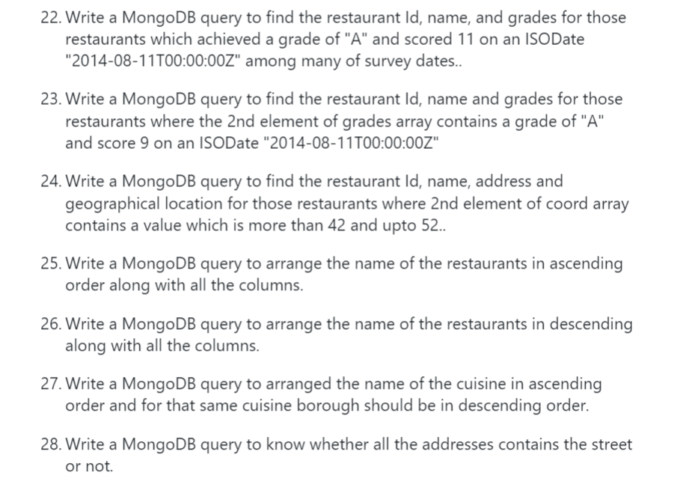

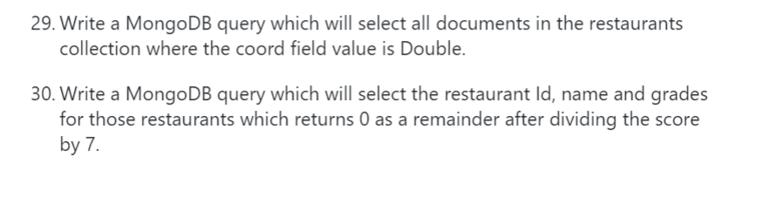

**Comments & Results:**

**db.restaurants.find(**

**... {**

**... "grades.date": ISODate("2014-08-11T00:00:00Z"),**

**... "grades.grade":"A" ,**

**... "grades.score" : 11**

**... },**

**... {"restaurant_id" : 1,"name":1,"grades":1}**

**... ).pretty()**

{

"_id" : ObjectId("60e1322cb0aed98e1e7af793"),

"grades" : [

{

"date" : ISODate("2014-08-11T00:00:00Z"),

"grade" : "A",

"score" : 13

},

{

"date" : ISODate("2013-07-22T00:00:00Z"),

"grade" : "A",

"score" : 9

},

{

"date" : ISODate("2013-03-14T00:00:00Z"),

"grade" : "A",

"score" : 12

},

{

"date" : ISODate("2012-07-02T00:00:00Z"),

"grade" : "A",

"score" : 11

},

{

"date" : ISODate("2012-02-02T00:00:00Z"),

"grade" : "A",

"score" : 10

},

{

"date" : ISODate("2011-08-24T00:00:00Z"),

"grade" : "A",

"score" : 11

}

],

"name" : "Neary'S Pub",

"restaurant_id" : "40365871"

}..continues....

**db.restaurants.find(**

**... { "grades.1.date": ISODate("2014-08-11T00:00:00Z"),**

**... "grades.1.grade":"A" ,**

**... "grades.1.score" : 9**

**... },**

**... {"restaurant_id" : 1,"name":1,"grades":1}**

**... ).pretty()**

{

"_id" : ObjectId("60e1322cb0aed98e1e7afd40"),

"grades" : [

{

"date" : ISODate("2015-01-12T00:00:00Z"),

"grade" : "A",

"score" : 10

},

{

"date" : ISODate("2014-08-11T00:00:00Z"),

"grade" : "A",

"score" : 9

},

{

"date" : ISODate("2014-01-14T00:00:00Z"),

"grade" : "A",

"score" : 13

},

{

"date" : ISODate("2013-02-07T00:00:00Z"),

"grade" : "A",

"score" : 10

},

{

"date" : ISODate("2012-04-30T00:00:00Z"),

"grade" : "A",

"score" : 11

}

],

"name" : "Club Macanudo (Cigar Bar)",

"restaurant_id" : "40526406"}

**db.restaurants.find(**

**... {**

**... "address.coord.1": {$gt : 42, $lte : 52}**

**... },**

**... {"restaurant_id" : 1,"name":1,"address":1,"coord":1}**

**... ).pretty()**

{

"_id" : ObjectId("60e1322cb0aed98e1e7af9b7"),

"address" : {

"building" : "47",

"coord" : [

-78.877224,

42.89546199999999

],

"street" : "Broadway @ Trinity Pl",

"zipcode" : "10006"

},

"name" : "T.G.I. Friday'S",

"restaurant_id" : "40387990"

}...continues..

**db.restaurants.find().sort({"name":1}).pretty()**

{

"_id" : ObjectId("60e1322db0aed98e1e7b03a5"),

"address" : {

"building" : "129",

"coord" : [

-73.962943,

40.685007

],

"street" : "Gates Avenue",

"zipcode" : "11238"

},

"borough" : "Brooklyn",

"cuisine" : "Italian",

"grades" : [

{

"date" : ISODate("2014-03-06T00:00:00Z"),

"grade" : "A",

"score" : 5

},

{

"date" : ISODate("2013-08-29T00:00:00Z"),

"grade" : "A",

"score" : 2

},

{

"date" : ISODate("2013-03-08T00:00:00Z"),

"grade" : "A",

"score" : 7

},

{

"date" : ISODate("2012-06-27T00:00:00Z"),

"grade" : "A",

"score" : 7

},

{

"date" : ISODate("2011-11-17T00:00:00Z"),

"grade" : "A",

"score" : 12

}

],

"name" : "(Lewis Drug Store) Locanda Vini E Olii",

"restaurant_id" : "40804423"

}...continues..

**db.restaurants.find().sort(**

**... {"name":-1}**

**... ).pretty()**

{

"_id" : ObjectId("60e1322cb0aed98e1e7af7d4"),

"address" : {

"building" : "6946",

"coord" : [

-73.8811834,

40.7017759

],

"street" : "Myrtle Avenue",

"zipcode" : "11385"

},

"borough" : "Queens",

"cuisine" : "German",

"grades" : [

{

"date" : ISODate("2014-09-24T00:00:00Z"),

"grade" : "A",

"score" : 11

},

{

"date" : ISODate("2014-04-17T00:00:00Z"),

"grade" : "A",

"score" : 7

},

{

"date" : ISODate("2013-03-12T00:00:00Z"),

"grade" : "A",

"score" : 13

},

{

"date" : ISODate("2012-10-02T00:00:00Z"),

"grade" : "A",

"score" : 9

},

{

"date" : ISODate("2012-05-09T00:00:00Z"),

"grade" : "A",

"score" : 13

},

{

"date" : ISODate("2011-12-28T00:00:00Z"),

"grade" : "B",

"score" : 24

}

],

"name" : "Zum Stammtisch",

"restaurant_id" : "40367377"

}....continues..

**db.restaurants.find().sort(**

**... {"cuisine":1,"borough" : -1,}**

**... ).pretty()**

{

"_id" : ObjectId("60e1322cb0aed98e1e7afe00"),

"address" : {

"building" : "1345",

"coord" : [

-73.959249,

40.768076

],

"street" : "2 Avenue",

"zipcode" : "10021"

},

"borough" : "Manhattan",

"cuisine" : "Afghan",

"grades" : [

{

"date" : ISODate("2014-10-07T00:00:00Z"),

"grade" : "A",

"score" : 9

},

{

"date" : ISODate("2013-10-23T00:00:00Z"),

"grade" : "A",

"score" : 8

},

{

"date" : ISODate("2012-10-26T00:00:00Z"),

"grade" : "A",

"score" : 13

},

{

"date" : ISODate("2012-04-26T00:00:00Z"),

"grade" : "A",

"score" : 7

},

{

"date" : ISODate("2012-01-12T00:00:00Z"),

"grade" : "P",

"score" : 10

}

],

"name" : "Afghan Kebab House",

"restaurant_id" : "40552806"

}...continues...

**db.restaurants.find(**

**... {"address.street" :**

**... { $exists : true }**

**... }**

**... ).pretty()**

{

"_id" : ObjectId("60e1322cb0aed98e1e7af715"),

"address" : {

"building" : "1007",

"coord" : [

-73.856077,

40.848447

],

"street" : "Morris Park Ave",

"zipcode" : "10462"

},

"borough" : "Bronx",

"cuisine" : "Bakery",

"grades" : [

{

"date" : ISODate("2014-03-03T00:00:00Z"),

"grade" : "A",

"score" : 2

},

{

"date" : ISODate("2013-09-11T00:00:00Z"),

"grade" : "A",

"score" : 6

},

{

"date" : ISODate("2013-01-24T00:00:00Z"),

"grade" : "A",

"score" : 10

},

{

"date" : ISODate("2011-11-23T00:00:00Z"),

"grade" : "A",

"score" : 9

},

{

"date" : ISODate("2011-03-10T00:00:00Z"),

"grade" : "B",

"score" : 14

}

],

"name" : "Morris Park Bake Shop",

"restaurant_id" : "30075445"

}...continues...

**db.restaurants.find(**

**... {"address.coord" :**

**... {$type : 1}**

**... }**

**... ).pretty()**

{

"_id" : ObjectId("60e1322cb0aed98e1e7af715"),

"address" : {

"building" : "1007",

"coord" : [

-73.856077,

40.848447

],

"street" : "Morris Park Ave",

"zipcode" : "10462"

},

"borough" : "Bronx",

"cuisine" : "Bakery",

"grades" : [

{

"date" : ISODate("2014-03-03T00:00:00Z"),

"grade" : "A",

"score" : 2

},

{

"date" : ISODate("2013-09-11T00:00:00Z"),

"grade" : "A",

"score" : 6

},

{

"date" : ISODate("2013-01-24T00:00:00Z"),

"grade" : "A",

"score" : 10

},

{

"date" : ISODate("2011-11-23T00:00:00Z"),

"grade" : "A",

"score" : 9

},

{

"date" : ISODate("2011-03-10T00:00:00Z"),

"grade" : "B",

"score" : 14

}

],

"name" : "Morris Park Bake Shop",

"restaurant_id" : "30075445"

}...continues..

**db.restaurants.find(**

**... {"grades.score" :**

**... {$mod : [7,0]}**

**... },**

**... {"restaurant_id" : 1,"name":1,"grades":1}**

**... ).pretty()**

{

"_id" : ObjectId("60e1322cb0aed98e1e7af715"),

"grades" : [

{

"date" : ISODate("2014-03-03T00:00:00Z"),

"grade" : "A",

"score" : 2

},

{

"date" : ISODate("2013-09-11T00:00:00Z"),

"grade" : "A",

"score" : 6

},

{

"date" : ISODate("2013-01-24T00:00:00Z"),

"grade" : "A",

"score" : 10

},

{

"date" : ISODate("2011-11-23T00:00:00Z"),

"grade" : "A",

"score" : 9

},

{

"date" : ISODate("2011-03-10T00:00:00Z"),

"grade" : "B",

"score" : 14

}

],

"name" : "Morris Park Bake Shop",

"restaurant_id" : "30075445"

}...continues....

**Questions:**

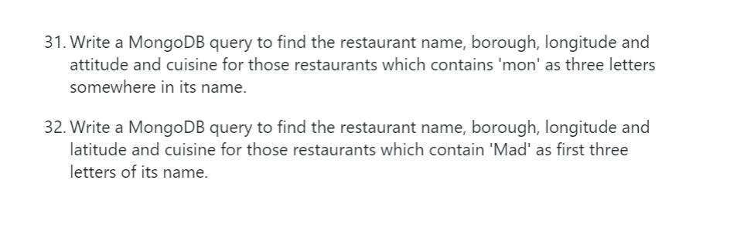

**Comments & Results:**

**db.restaurants.find(**

**... { name :**

**... { $regex : "mon.*", $options: "i" }**

**... },**

**... {**

**... "name":1,**

**... "borough":1,**

**... "address.coord":1,**

**... "cuisine" :1**

**... }**

**... ).pretty()**

{

"_id" : ObjectId("60e1322cb0aed98e1e7af7a9"),

"address" : {

"coord" : [

-73.98306099999999,

40.7441419

]

},

"borough" : "Manhattan",

"cuisine" : "American ",

"name" : "Desmond'S Tavern"

}...continue...

**db.restaurants.find(**

**... { name :**

**... { $regex : /^Mad/i, }**

**... },**

**... {**

**... "name":1,**

**... "borough":1,**

**... "address.coord":1,**

**... "cuisine" :1**

**... }**

**... ).pretty()**

{

"_id" : ObjectId("60e1322cb0aed98e1e7afc51"),

"address" : {

"coord" : [

-73.9860597,

40.7431194

]

},

"borough" : "Manhattan",

"cuisine" : "American ",

"name" : "Madison Square"

}

{

"_id" : ObjectId("60e1322cb0aed98e1e7afd1f"),

"address" : {

"coord" : [

-73.98302199999999,

40.742313

]

},

"borough" : "Manhattan",

"cuisine" : "Indian",

"name" : "Madras Mahal"

}